Best SARIMAX order (v3): (2, 1, 0) (1, 0, 1, 7) CV MAPE: 15.971854292042869
Best GRU v3 cfg: {'units1': 160, 'units2': 96, 'dropout': 0.25, 'window': 28} val_loss: 0.11810231953859329

=== HOLDOUT (28d) RESULTS — v3 seasonal+weekday head ===
MAE: 305.19
RMSE: 470.58
MAPE: 9.63%
Accuracy (1-MAPE): 90.37%
SARIMAX-only MAPE: 15.23% → ΔMAPE vs Hybrid: +5.61 pts
gamma=1.113, delta=0.000, alpha=0.000, beta=227.703
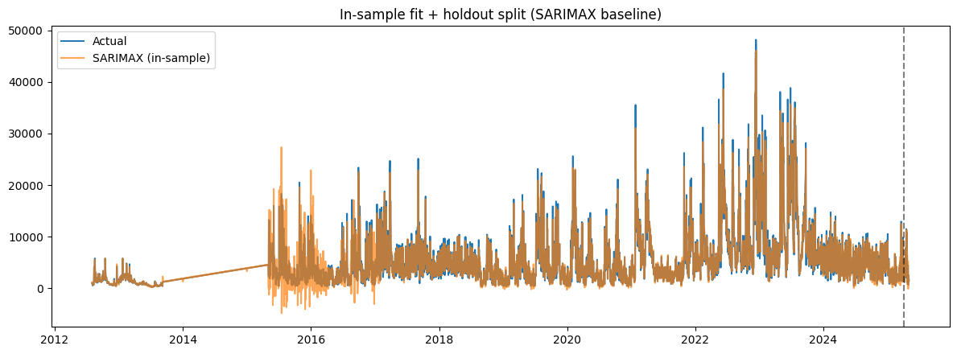
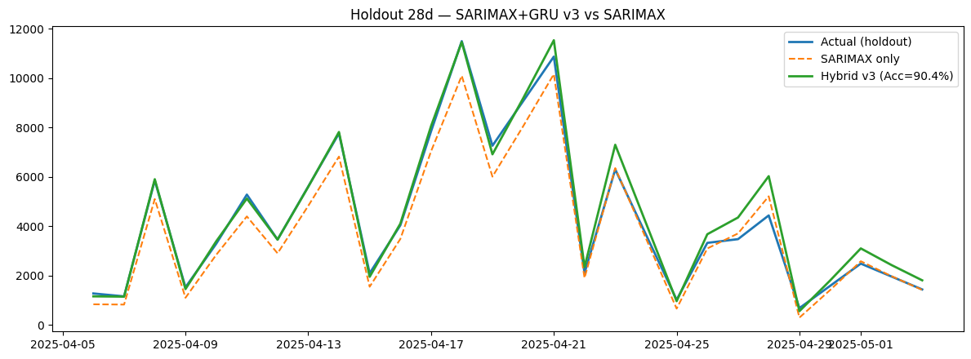
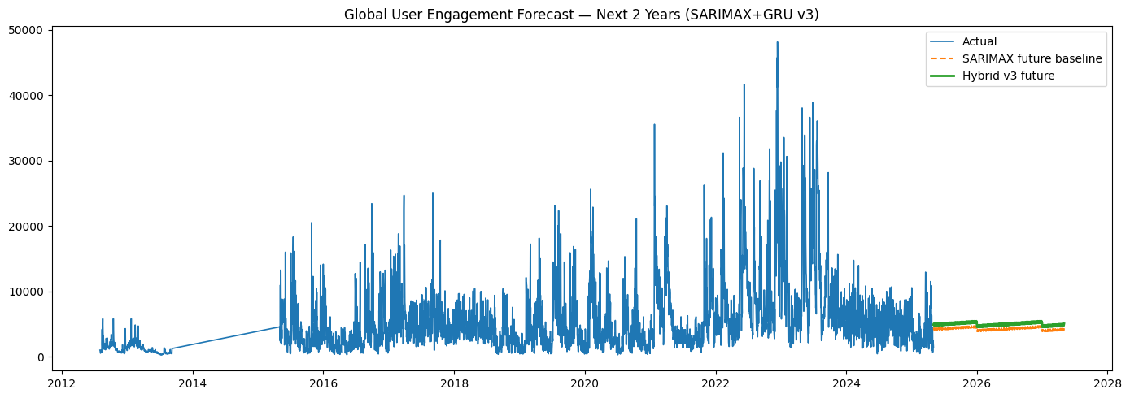

Artifacts: /content/hybrid_arima_gru_v3_artifacts
- 2year_forecast_sarimax_gru_v3.csv
- gru_v3_dynamic.keras
- metrics_sarimax_gru_v3.json
- sarimax_order_v3.json
- sarimax_v3_model.pkl
- x_scaler_v3.npy
- y_scaler_v3.npy

Checkpoints: /content/arima_gru_v3_ckpts
- gru_v3_best_win21.keras
- gru_v3_best_win28.keras

